

They come trickling in, the hungover, the sick and weary, the jubilant and the hungry. No, I’m not talking about early morning Mc Donalds breakfast, I’m talking about the Monday morning after O-week! So take this next week to actually start considering what university is, relax, and maybe even (shock horror) meet people outside of Bruce…..

*Doing it for Bill since 2014*

THE BRUCE BILLITIN

**ISSUE 02: Monday 15th February- Sunday 21st February**

*Doing it for Bill since 2014*

THE MANY WONDERS OF CANBERRA



Canberra is a land where dreams are made, dreams which are promptly pursued elsewhere. However, it is also a place in which there are many going ons, such as the following titbits this next week:

* **Guy Sebastian Live at the National Convention Centre (16th February):** Bring along your goatees and/or afros to watch the man who robbed Shannon Noll of his rightfully deserved prize.
* **University of Canberra Capitals vs Bendigo (20th February AIS arena)**
* **Canberra Food & Wine Expo (National Convention Centre 19th- 21st February)**

Furthermore the National Gallery and National Library have multiple exciting exhibitions on, with the national library focusing on Chinese history for this next week. For more events go to: http://visitcanberra.com.au/events/find

Essentially ANU university life summed up in a single photo

BRUCE HALL: An interactive Guide

Coming up this next week we have a compulsory academic orientation session for all first years. Essentially this session will introduce you to Bruce’s very fine academic team, a group of people who will go above and beyond to ensure that this year will not be one in which academics pose a problem. The session is on **Tuesday the 16th at 7:30pm in the Dining Hall.** It is compulsory for all first years and new residents, and if any of you second years need a brush up, you are welcome to come along as well. There will also be snacks and food on the tables for all of you who aren’t quite used to the 5:30 pm dinner time.

Commencement dinner is also coming up on the 4th of March, so get excited for what is a great night for everyone! Also keep a close eye on banter for any upcoming events, as we have got a packed social calendar planned for you!

SCHIMDT HAPPENS- What’s on in ANU

After O-week, there isn’t a massive amount going on in the wilds of ANU. Lecturers are buckling down, students are dosing themselves with copious amounts of caffeine and the staff are holding out lanterns to direct all the first years in the right direction.

Throughout the next week there are multiple public lectures available, all of which can be found listed on the following website: [www.anu.edu.au/events](http://www.anu.edu.au/events)



*Humour is everywhere, in that there is irony in everything a human does -* Bill Nye



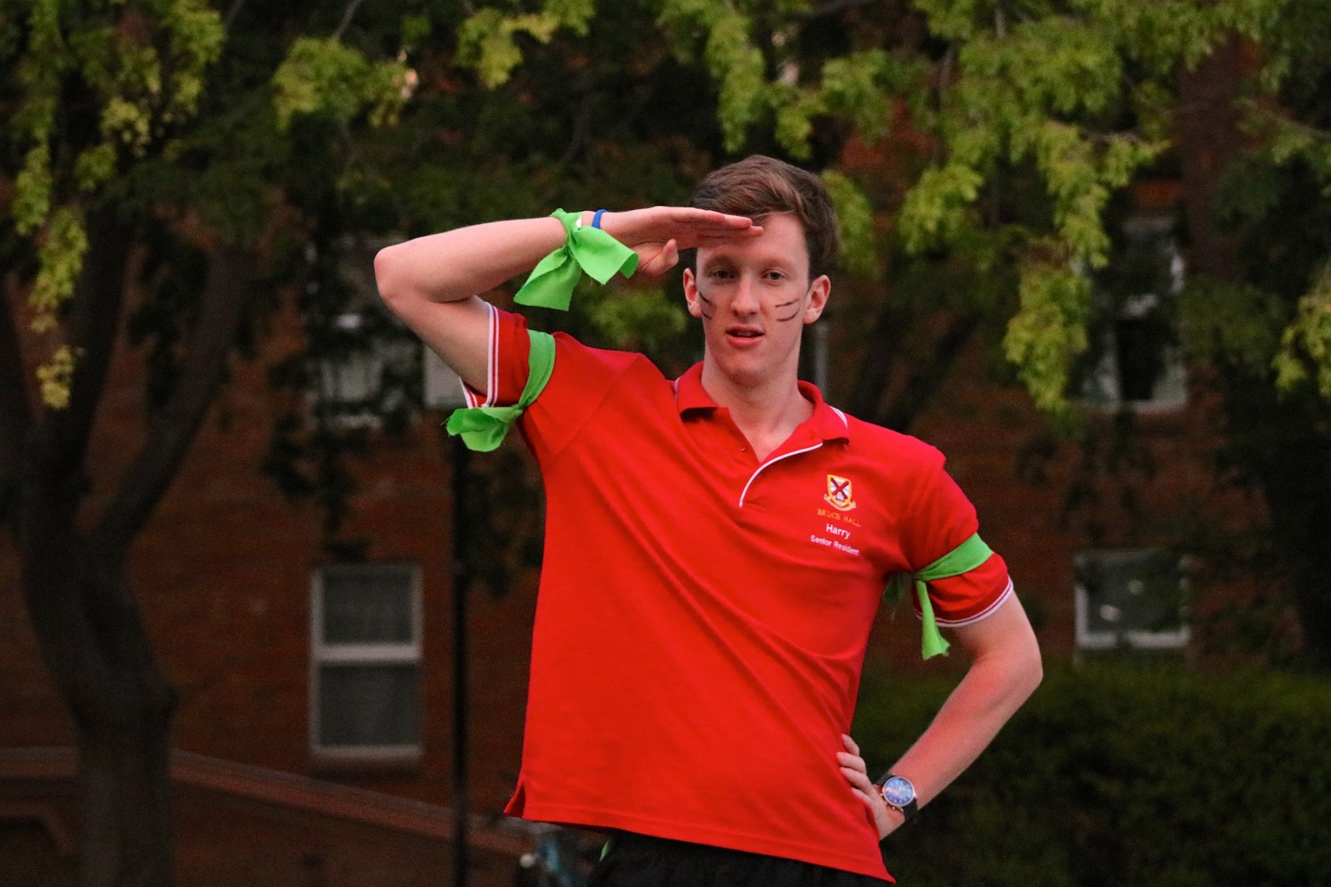

ANU ON THE INTERNET-  
With Harry Main

As Bruce Hall’s resident BNOS (Big Name on Stalkerspace) I am  
in probably the best position to educate all you unfortunate   
novices about the many tentacled beast that is ANU’s internet  
presence. I mean, I once got almost 500 likes on a single photo of me on  
ANU stalkerspace, so seriously, pay attention. I’ll start with the   
far inferior “**official**” sites and then move to the much more  
entertaining (read: procrastination enabling) unofficial facebook pages.

**WATTLE**

Apparently updated over the summer, Wattle is your one stop shop  
for discovering what your lecturers are actually going on about.  
All the course outlines are available here, as well as a link to the ECHO where you can find the ever useful lecture recordings, a website which over the course of last year became like a second home to me.

**ISIS**

Since its name was borrowed without the ANU’s permission, ISIS has undergone much confusion. Despite what ASIO may think, it is actually the administrative centre for ANU’s students. Here you can actually enrol in that ceramics course you have always wanted to do, or find out just how far into debt you are, or even just bring up your past grades to boast of to your unsuspecting peers.

**ANU STALKERSPACE**

Here it is. The page which has everything. Dank memes, political discussions, random thesis streaming, Car park inspectors and even your occasional genuinely useful bit of info. It was here, in the hallowed days of the Semester 2 exam period of 2015 that I became internet famous, taking advantage of ANUS Talkerspace’s propensity for cats to gain a name as one of the true progenitors of the meme.

**ANU FREE & SALE**

For whenever you feel like you actually do need to buy that gardening equipment for the fake pot plant flowering outside your door. ANU Free & for sale is a bountiful site on which people buy, sell and give away pretty much everything. You balcony looking a bit too empty? Your fridge not quite full enough with left over pancake mix? Your wardrobe missing that extra unwanted dress? ANU free & for sale can solve all these problems and more, so head on down!

So there you have it, a definitive guide to the most important sites for any student at this university that we all call ours. Enjoy yourself as you traverse the wild of ANU’s internet presence, be wary of cats, foxes and the occasional shitpost, and hopefully some day you too may join the ranks of the BNOS. (Disclaimer: I will not be held liable for the presence of the many hundreds of other ANU related sites available to a student. There are too many of them and quite frankly, even I don’t know them all… so do some exploring and enjoy!)

TRIVIA

1. What is the sixth richest monarchy in the world? 6. What year was Brian Schmidt awarded his Nobel Prize?

2. What was the first artificially manufactured organic chemical? 7. How many books are there in Terry Pratchett’s Discworld

3. Who on the English Premier League in 2013/14? Series?

4. When was the first car powered by an internal combustion engine 8. Where is the seat of government in Holland?

Made? 9. What was the name of the Arctic Monkey’s third album?

5. What is the current waffle fry special available at the Mandalay 10. What decade did Batman first appear in a comic?

Bus?



1. Lichtenstein Monarchy, 2. Urea, 3. Manchester City, 4. 1807, 5. Nachos Chilli waffle fries, 6. 2011, 7. 41, 8. Den Hague, 9. Humbug, 10. 1930’s